 | 12.1.20 Editors - Geometry Nodes Editor - Header - Add Menu - Utilities
Table of content
Detailed table of content 1
Add menu - Utilities 6
Accumulate Field 6
Align Euler to Vector 7
Boolean Math 7
Clamp 8
Compare 9
Field at Index 10
Field on Domain 11
Float Curve 12
Float to Integer 14
Map Range 14
Math 15
Random Value 19
Rotate Euler 20
Switch 21

Detailed table of content
Detailed table of content
Detailed table of content 1
Add menu - Utilities 6
Accumulate Field 6
Inputs 6
Value 6
Group Index 6
Properties 6
Data Type 6
Outputs 6
Leading and Trailing 6
Total 6
Align Euler to Vector 7
Inputs 7
Rotation 7
Factor 7
Vector 7
Properties 7
Align Axis 7
Pivot 7
Output 7
Rotation 7
Boolean Math 7
Inputs 7
Boolean 7
Properties 8
Operation 8
And 8
Or 8
Not 8
Not And (NAND) 8
Nor (NOR) 8
Equal (XNOR) 8
Not Equal (XOR) 8
Imply (IMPLY) 8
Subtract (NIMPLY) 8
Output 8
Clamp 8
Inputs 8
Value 8
Min 9
Max 9
Properties 9
Clamp Type 9
Min Max 9
Range 9
Outputs 9
Result 9
Compare 9
Inputs 9
A, B 9
Properties 9
Input Type 9
Operation 10
A is less than B 10
A is lesser than or equal B 10
A is greater than B 10
A is greater than or equal B 10
A is equal B 10
A is not equal B 10
Output 10
Result 10
Field at Index 10
Inputs 10
Index 10
Value 10
Properties 10
Data Type 10
Domain 11
Output 11
Value 11
Field on Domain 11
Inputs 11
Value 11
Properties 11
Data Type 11
Domain 11
Outputs 11
Value 11
Float Curve 12
Inputs 12
Factor 12
Attribute 12
Properties 12
Curve Field 12
Channel buttons 12
Navigation elements 12
Zoom in and out 12
Use Clipping 12
Tools 12
Reset View 12
Extend horizontal 12
Extend extrapolated 13
Reset Curve 13
Curve edit field 13
Selecting Points 13
Adding Points 13
Curve point settings 13
Vector Handle 13
Auto Handle 13
Auto Clamped Handle 13
Output 13
Value 13
Float to Integer 14
Inputs 14
Float 14
Properties 14
Rounding Mode 14
Outputs 14
Integer 14
Map Range 14
Inputs 14
Value 14
From Min 14
From Max 14
To Min 14
To Max 14
Properties 15
Data Type 15
Interpolation Type 15
Clamp 15
Outputs 15
Value 15
Math 15
Inputs 15
Value 15
Addend 15
Base 15
Exponent 15
Epsilon 15
Distance 15
Min 16
Max 16
Increment 16
Scale 16
Degrees 16
Radians 16
Properties 16
Operation 16
Functions 16
Add 16
Subtract 16
Multiply 16
Divide 16
Multiply Add 16
Power 16
Logarithm 17
Square Root 17
Inverse Square Root 17
Absolute 17
Exponent 17
Comparison 17
Minimum 17
Maximum 17
Less Than 17
Greater Than 17
Sign 17
Compare 17
Smooth Minimum 17
Smooth Maximum 17
Rounding 17
Round 17
Floor 17
Ceil 18
Truncate 18
Fraction 18
Modulo 18
Wrap 18
Snap 18
Ping-pong 18
Trigonometric 18
Sine 18
Cosine 18
Tangent 18
Arcsine 18
Arccosine 18
Arctangent 18
Arctan2 18
Hyperbolic Sine 18
Hyperbolic Cosine 18
Hyperbolic Tangent 19
Conversion 19
To Radians 19
To Degrees 19
Clamp 19
Outputs 19
Value 19
Use Clipping 19
Delete Points 19
Curve window 19
X / Y values 19
Random Value 19
Input 19
Min 19
Max 20
ID 20
Seed 20
Properties 20
Data Type 20
Output 20
Value 20
Rotate Euler 20
Inputs 20
Rotation 20
Rotate By 20
Properties 20
Rotate Type 20
Axis Angle 20
Euler 20
Rotate Space 21
Object 21
Point 21
Outputs 21
Rotation 21
Switch 21
Inputs 21
Switch 21
A 21
B 21
Properties 21
Input Type 21
Outputs 22
Output 22

Add menu - Utilities
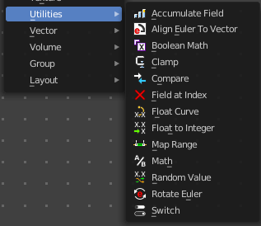
Utility nodes are mainly for mathematical operations.

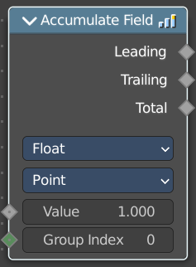
Accumulate Field
Creates a running total of a given Vector, Float, or Int field.

Inputs

Value
The field to be accumulated.

Group Index
The values of this input are used to aggregate the input into separate 'bins', creating multiple accumulations.

Properties

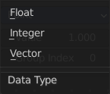
Data Type
What data type to work with.

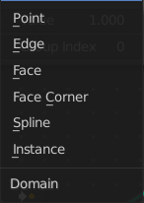
Domain
From which domain to use the data.

Outputs

Leading and Trailing
Returns the running totals starting at either the first value of each accumulations or 0 if there is no data

Total
Returns the total accumulation at all positions of the field.

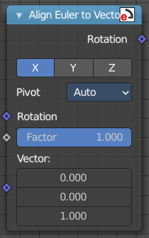
Align Euler to Vector
Aligns a euler value to a vector.

Inputs

Rotation
The input euler rotation vector.

Factor
The factor to align the euler value to the vector.

Vector
The vector to align to.

Properties

Align Axis
To which axis to align the vector.

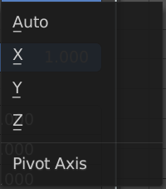
Pivot
The pivot axis.

Output

Rotation
The output rotation euler angle.

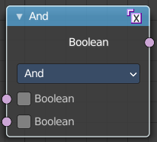
Boolean Math
The Boolean Math node performs a basic logical operation between its inputs.

Inputs

Boolean
Two standard Boolean inputs.

Properties

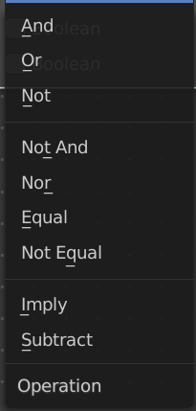
Operation

And
True if both inputs are true.

Or
True if either or both inputs are true.

Not
True if both inputs are false.

Not And (NAND)
True when at least one input is false.

Nor (NOR)
True when both inputs are false.

Equal (XNOR)
True when both inputs are equal.

Not Equal (XOR)
True when both inputs are different.

Imply (IMPLY)
True unless the first input is true and the second is false.

Subtract (NIMPLY)
True when the first input is true and the second is false.

Output
Boolean
Standard Boolean output.

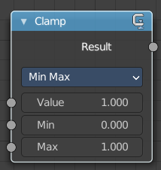
Clamp
Clamps a value between a minimum and a maximum.

Inputs

Value
The input value to be clamped.

Min
The minimum value.

Max
The maximum value.

Properties

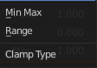
Clamp Type

Min Max
Clamp values using Min and Max values.

Range
Clamp values between Min and Max range.

Outputs

Result
The input value after clamping.

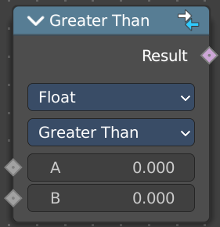
Compare
The Compare node takes two inputs and does a math comparison between them.

Inputs

A, B
Standard float value input.

Properties

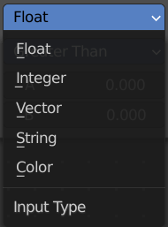
Input Type
What kind of data to compare.

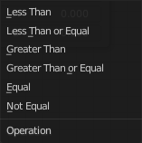
Operation

A is less than B
True if A is smaller than B.

A is lesser than or equal B
True if A is smaller or equal than B.

A is greater than B
True if A is bigger than B.

A is greater than or equal B
True if A is bigger or equal than B.

A is equal B
True if A and B are the same.

A is not equal B
True if A and B are different.

Output

Result
Standard Boolean output.

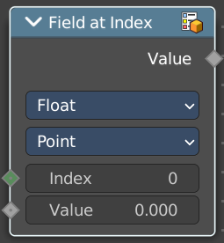
Field at Index
This node allows accessing data of other elements in the context geometry.
It is similar to the Transfer Attribute node in Index mode. The main difference
is that this node does not require a geometry input, because the context
is used.

Inputs

Index
Input Index.

Value
Input Value.

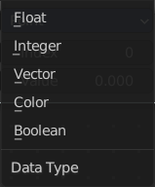
Properties

Data Type
What data type to calculate.

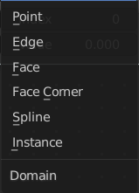
Domain
What geometry to calculate.

Output

Value
The output value.

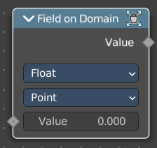
Field on Domain
This node evaluates an existing field on a separate domain in a larger field context - an alternative to the Capture Attribute node. This nodes gets the field type of an existing field from the input socket and isolates the field type as an array in the output socket.

Inputs

Value
The input value to get the field.

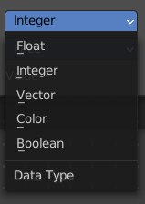
Properties

Data Type
Select the Data Type - which can be float, integer, vector, color and boolean.

Domain
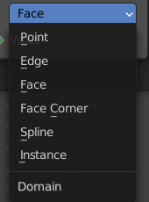
The domain the Field evaluates. This gets and filters the field type. The domain can be point, edge, face, face corner, spline or instance.

Outputs

Value
The output value.

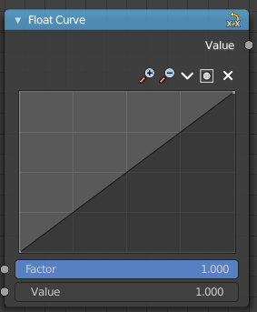
Float Curve
The Float Curve node maps an input float to a curve and outputs a float value. This curve can then be used for profiles for example.

Inputs

Factor
How strong the input influences the output value.

Attribute
The input value.

Properties

Curve Field

Channel buttons
Clicking on one of the channels displays the curve for each.
C (Combined RGB), R (Red), G (Green), B (Blue).

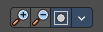
Navigation elements
They are described from left to right.

Zoom in and out
The two buttons with the magnifying glass at it zooms in and out in the curve window.


Use Clipping
Clipping options. Set up clipping for the stroke.

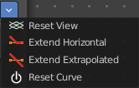
Tools
Tools is a menu where you can find some curve related tools.

Reset View
Resets the curve windows zoom.

Extend horizontal
Extends the curve before the first curve point and behind the last curve point horizontally.

Extend extrapolated
Extends the curve before the first curve point and behind the last curve point extrapolated.

Reset Curve
Resets the curve to the initial shape.

Curve edit field
Create and tweak a Bezier curve that varies the input levels (X axis) to produce an output level (Y axis).

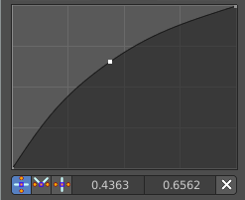
Selecting Points
You can select curve points. This reveals two edit boxes for the x and y coordinate of this point.
Selected points can be moved around. Left click at them, hold the mouse button down and move them to a new location.

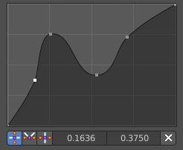
Adding Points
You can add new curve points by simply left clicking at the curve. Move the mouse to position them where you need it.

Curve point settings
When you have a point selected then you will reveal further settings at the bottom.

Vector Handle
Set handle type to Vector.

Auto Handle
Set handle type to Auto.

Auto Clamped Handle
Set handle type to Auto Clamped.

Output

Value
The output value.

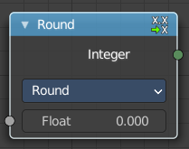
Float to Integer
Converts a floating point value into an integer value.

Inputs

Float
The input float value.

Properties

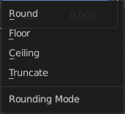
Rounding Mode
How the float value should be converted.

Outputs

Integer
The output integer value.

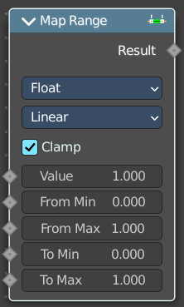
Map Range
This node converts (maps) an input value range into a destination range. By default, values outside the specified input range will be proportionally mapped as well. This node is similar to Map Value node but provides a more intuitive way to specify the desired output range.

Inputs

Value
Standard value input.

From Min
Start of the input value range.

From Max
End of the input value range.

To Min
Startof the destination range.

To Max
End of the destination range.

Properties

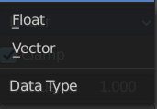
Data Type
The data type to calculate.

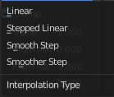
Interpolation Type
how to interpolate the values between min and max.

Clamp
Clamps values to Min/Max of the destination range.

Outputs

Value
Standard value output.

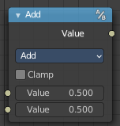
Math
The Math Node performs math operations.

Inputs
The inputs of the node are dynamic. Some inputs are only available with certain operations. For example, the Addend input is only available in the Multiply Add operator.

Value
Input Value. Trigonometric functions read this value as radians.

Addend
Input Addend.

Base
Input Base.

Exponent
Input Exponent.

Epsilon
Input Epsilon.

Distance
Input Distance.

Min
Input Minimum.

Max
Input Maximum.

Increment
Input Increment.

Scale
Input Scale.

Degrees
Input Degrees.

Radians
Input Radians.

Properties

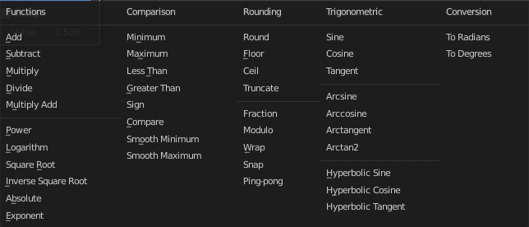
Operation
The mathematical operator to be applied to the input values:

Functions

Add
The sum of the two values.

Subtract
The difference between the two values.

Multiply
The product of the two values.

Divide
The division of the first value by the second value.

Multiply Add
The sum of the product of the two values with Addend.

Power
The Base raised to the power of Exponent.

Logarithm
The log of the value with a Base as its base.

Square Root
The square root of the value.

Inverse Square Root
One divided by the square root of the value.

Absolute
The input value is read with without regard to its sign. This turns negative values into positive values.

Exponent
Raises Euler’s number to the power of the value.

Comparison

Minimum
Outputs the smallest of the input values.

Maximum
Outputs the largest of two input values.

Less Than
Outputs 1.0 if the first value is smaller than the second value. Otherwise the output is 0.0.

Greater Than
Outputs 1.0 if the first value is larger than the second value. Otherwise the output is 0.0.

Sign
Extracts the sign of the input value. All positive numbers will output 1.0. All negative numbers will output -1.0. And 0.0 will output 0.0.

Compare
Outputs 1.0 if the difference between the two input values is less than or equal to Epsilon.

Smooth Minimum
Smooth Minimum.

Smooth Maximum
Smooth Maximum.

Rounding

Round
Round the input value to the nearest integer.

Floor
Rounds the input value down to the nearest integer.

Ceil
Rounds the input value up to the nearest integer.

Truncate
Outputs the integer part of the value.

Fraction
Fraction.

Modulo
Outputs the remainder once the first value is divided by the second value.

Wrap
Outputs a value between Min and Max based on the absolute difference between the input value and the nearest integer multiple of Max less than the value.

Snap
Round the input value to down to the nearest integer multiple of Increment.

Ping-pong
The output value is moved between 0.0 and the Scale based on the input value.

Trigonometric

Sine
The Sine of the input value.

Cosine
The Cosine of the input value.

Tangent
The Tangent of the input value.

Arcsine
The Arcsine of the input value.

Arccosine
The Arccosine of the input value.

Arctangent
The Arctangent of the input value.

Arctan2
Outputs the Inverse Tangent of the first value divided by the second value measured in radians.

Hyperbolic Sine
The Hyperbolic Sine of the input value.

Hyperbolic Cosine
The Hyperbolic Cosine of the input value.

Hyperbolic Tangent
The Hyperbolic Tangent of the input value.

Conversion

To Radians
Converts the input from degrees to radians.

To Degrees
Converts the input from radians to degrees.

Clamp
Limits the output to the range (0.0 to 1.0). See Clamp.

Outputs

Value
Numerical value output.


Use Clipping
Clipping options. Set up clipping for the stroke.

Delete Points
Deletes selected curve point.

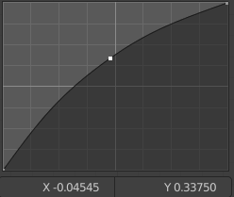
Curve window
Tweak and adjust the falloff curve by clicking at a curve point and dragging it around.
Double click adds a new point.
Holding down ctrl activates temporary snapping.
Holding down shift enables slower movement, which allows more accurate setting.

X / Y values
The x and y value of the currently selected point.

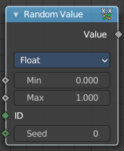
Random Value
Generates a random value.

Input

Min
The minimum value of the range. This input is only available for Float, Integer, and Vector types.

Max
The maximum value of the range. This input is only available for Float, Integer, and Vector types.

ID
An ID to drive the random number generator seed. By default, this input uses the same value as if the ID Node, which is the id attribute of the context geometry if it exists, and otherwise the index.

Seed
The random seed for the random number generation.

Properties

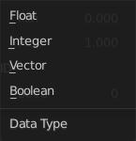
Data Type
What kind of random value to create. The items should be self explaining.

Output

Value
The output value.

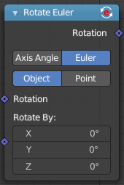
Rotate Euler
Rotates an euler rotation.

Inputs

Rotation
Use the rotation of an existing geometry.

Rotate By
The input rotation.

Properties

Rotate Type

Axis Angle
Rotate around an axis by an angle.

Euler
Rotate around the x, y and z axis.

Rotate Space

Object
Rotate points in the local space of the object.

Point
Rotate every point in its local space.

Outputs

Rotation
The euler angle output.

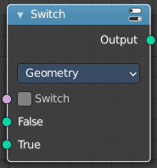
Switch
Switch between two inputs values based on a boolean.

Inputs

Switch
The boolean switch.

A
The input value A. Used when the switch is off.

B
The input value B. Used when the switch is on.

Properties

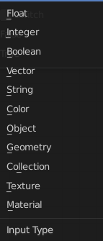
Input Type
What input type the values are, which defines what type to output then.

Outputs

Output
Numerical value output.

